**Smart public restroom**

**Project Objectives:** The project aims to create a smart environmental monitoring system that collects data from various IoT sensors, processes it using a Raspberry Pi, and provides users with real-time insights through a mobile app. The key objectives include environmental data collection, data processing, and user-friendly data visualization.

**IoT Sensor Setup:** The IoT sensor setup consists of various sensors like temperature, humidity, air quality, and light sensors. These sensors are strategically placed in the environment to collect real-time data. The sensors are typically connected to a microcontroller (e.g., Arduino) and communicate data through a wireless protocol (e.g., Wi-Fi or Bluetooth) to a central hub, which is often a Raspberry Pi.

**IOT sensor design:**

1. **Sensor Selection:**
   * Occupancy Sensors: Use infrared or ultrasonic sensors to detect when a person enters or leaves the restroom. This information can help with occupancy monitoring and cleaning schedules.
   * Toilet Stall Availability Sensors: Install sensors on toilet stall doors to indicate whether they are vacant or occupied.
   * Toilet Flush Sensors: Incorporate sensors on flush handles or automatic flushing mechanisms to monitor toilet usage.
   * Soap and Paper Dispenser Sensors: Equip soap and paper dispensers with sensors to monitor refill levels and usage.
   * Air Quality Sensors: Measure temperature, humidity, and air quality to ensure a comfortable environment.
   * Water Usage Sensors: Track water consumption for toilets and sinks to optimize resource usage.
   * Trash Bin Sensors: Install sensors in trash bins to alert maintenance staff when bins are full.
   * Toilet Seat Sensors: These sensors can help determine if toilet seats are up or down.
2. **Data Communication:**
   * Utilize wireless protocols like Wi-Fi, Bluetooth, or Zigbee for sensor data transmission to a central hub.
3. **Central Data Hub:**
   * Set up a central server or cloud platform to collect and process data from the sensors.
4. **User Interface:**
   * Create a user-friendly interface for restroom users. This can be a mobile app or a display within the restroom, showing stall availability, air quality, and other relevant information.
5. **Maintenance Alerts:**
   * Implement a notification system that sends alerts to cleaning staff or facility managers when certain conditions are met, like a toilet stall being used for an extended period or when soap or paper supplies are low.
6. **Energy Efficiency:**
   * Use energy-efficient sensors and implement power-saving strategies to prolong battery life or reduce energy consumption.
7. **Privacy and Security:**
   * Ensure data privacy and security. Collect and store data responsibly and in compliance with relevant regulations.
8. **Integration:**
   * Integrate the IoT system with building management systems for efficient facility operations.
9. **Analytics and Reporting:**
   * Develop data analytics to identify usage patterns, optimize cleaning schedules, and enhance resource allocation.
10. **Maintenance and Upkeep:**
    * Implement a regular maintenance schedule for sensors to ensure they are functioning correctly.
11. **Feedback Mechanism:**
    * Allow users to provide feedback on the restroom's cleanliness and functionality through the IoT system.
12. **Accessibility:**
    * Ensure that the smart restroom system is accessible to all users, including those with disabilities.
13. **Sustainability:**
    * Consider environmental sustainability by optimizing resource usage, such as water and energy, and using eco-friendly materials.
14. Compliance:
    * Ensure that the design complies with local building codes and regulations.
15. **Scalability:**
    * Design the system to be easily scalable to accommodate additional sensors or expanded restroom facilities.

**Real-time transit Information Platform:**

Creating a real-time transit information platform for IoT-enabled smart public restrooms can improve the overall user experience and ensure visitors have access to timely information about transit options. Here's a framework for designing such a platform:

**1.** **Sensors and Data Sources**:

* + **Occupancy Sensors**: As mentioned earlier, use occupancy sensors to monitor restroom usage and occupancy levels.
  + **Location Sensors**: Implement geolocation sensors to determine the restroom's location accurately.
  + **Local Transit Data Sources**: Integrate with local transit authorities or services to access real-time information about nearby bus and train schedules, routes, delays, and arrivals.

1. **User Interface**:
   * Develop a user-friendly interface accessible to restroom users. This can be a touchscreen display within the restroom or a mobile app. The interface should provide the following features:
     + Real-time transit information (e.g., bus and train arrival times, nearby stops, and routes).
     + Restroom occupancy information.
     + Maps and directions to the nearest transit stops.
     + Accessibility features for users with disabilities.
2. **Data Integration and Processing**:
   * Use cloud-based servers to process data from the sensors and external data sources.
   * Integrate APIs from local transit authorities or third-party transit data providers to fetch real-time transit information.
3. **Notification System**:
   * Implement a notification system that provides users with alerts about upcoming transit arrivals, delays, or critical information related to their journeys.
4. **User Feedback and Interaction**:
   * Allow users to provide feedback on the restroom experience and the transit information platform. Collect and act upon user suggestions and complaints.
5. **Accessibility and Multilingual Support**:
   * Ensure the platform is accessible to users with disabilities and provides content in multiple languages to accommodate a diverse user base.
6. **Security and Privacy**:
   * Protect user data and ensure privacy by following industry-standard security practices. Inform users about data collection and usage.
7. **Maintenance and Reliability**:
   * Establish a maintenance schedule for sensors, displays, and the entire platform to ensure it operates reliably. Implement redundancy and failover mechanisms to minimize downtime.
8. **Scalability and Expansion**:
   * Design the platform to be scalable to accommodate additional restrooms and transit stops, as well as potential future features or integration with other services.
9. **Integration with Other Services**:
   * Explore the possibility of integrating with other services, such as ride-sharing apps or bike-sharing services, to provide users with a comprehensive transportation experience.
10. **Energy Efficiency**:
    * Use energy-efficient components and implement power-saving strategies to minimize energy consumption.
11. **Promotion and Marketing**:
    * Promote the availability of the platform and its benefits to restroom users and the general public.
12. **Regulatory Compliance**:
    * Ensure that the platform complies with local regulations and data protection laws.

**Integrated Approach for smart public restroom:**

Creating a smart public restroom typically involves an integrated approach that combines various technologies and design principles. Here are key components for such a restroom

Smart Sensors: Install occupancy sensors for automatic lighting and ventilation control. Touchless faucets, soap dispensers, and flush systems can minimize the need for physical contact.

1. **Energy Efficiency**: Implement LED lighting and low-flow fixtures to reduce energy and water consumption.
2. **Hygiene and Sanitization**: Provide touchless hand sanitizers and trash disposal. Incorporate UV-C or other disinfection technologies to maintain cleanliness.
3. **Occupancy Management**: Use occupancy monitoring systems to display restroom availability, reducing wait times.
4. **Accessibility**: Ensure the restroom is accessible to people with disabilities, with features like accessible stalls and braille signage.
5. **Maintenance Alerts:** Install systems that automatically notify maintenance personnel when supplies are running low or when maintenance is required.
6. **High-Quality Materials**: Use durable, easy-to-clean materials to maintain a clean and presentable appearance.
7. **User Feedback**: Collect feedback from users to continuously improve the restroom experience.
8. **Environmental Sustainability**: Incorporate sustainable materials and practices, such as using recycled materials and efficient waste management.
9. **Security**: Consider security measures to ensure the safety of users, like surveillance cameras and emergency call buttons.
10. **Aesthetics and Comfort**: Design the restroom for comfort and aesthetics to provide a pleasant experience for users.
11. **Connectivity**: Offer Wi-Fi and charging stations for convenience.
12. **Smart Maintenance**: Use IoT devices to monitor restroom conditions and proactively address issues.
13. **Public Health Measures**: Include features that promote public health, such as touchless temperature checks or air quality monitoring.
14. **Cost Analysis**: Perform a cost-benefit analysis to determine the long-term savings and benefits of smart technologies.

**Solution:**

solution for a smart public restroom involves integrating various sensors and devices to enhance user experience, improve efficiency, and ensure cleanliness and safety. Here's a simplified solution:

1. **Occupancy Monitoring:** Implement occupancy sensors at the restroom entrance to detect the number of users. This information can be displayed outside the restroom to indicate availability and wait times.

2. **Automatic Lighting and Ventilation**: Use motion sensors to control lighting and ventilation, ensuring they are active only when the restroom is in use.

3. **Touchless Fixtures**: Install touchless faucets, soap dispensers, and flush systems to reduce physical contact and promote hygiene.

4. **Water and Energy Management:** Incorporate IoT sensors to monitor water and energy usage. Set up alerts for maintenance when there are leaks or inefficiencies.

5. **Real-time Feedback**: Provide a kiosk or mobile app for users to provide feedback on cleanliness and maintenance issues. Maintenance teams receive alerts for quick response.

6. **Cleaning Schedules**: Utilize IoT devices to monitor restroom usage and automatically adjust cleaning schedules based on foot traffic

7. **Waste Management:** Implement smart waste bins that notify staff when they need emptying. This minimizes overflow and maintains cleanliness.

8. **Environmental Sensors**: Use IoT sensors to monitor air quality, humidity, and temperature, ensuring a comfortable environment for users.

9. **Security and Safety:** Install security cameras and panic buttons for emergencies. IoT devices can automatically alert authorities in case of security issues.

10. **Maintenance Predictive Analytics:** Employ data analytics to predict when fixtures and equipment might require maintenance, reducing downtime.

11. **Smart Locks:** Implement smart locks on stalls that indicate if they are occupied or vacant.

12. **Accessibility Features**: Include IoT-controlled features like automatic doors for accessibility.

13**.Mobile App Integration**: Allow users to locate and access the restroom using a mobile app, which can provide real-time information and user reviews.

14. **Analytics and Reporting:** Collect and analyze data on usage patterns, feedback, and resource consumption to continuously improve the restroom's performance.

15. **Sustainability:** Promote sustainability by using renewable energy sources, eco-friendly materials, and efficient resource management.

16.**Public Health Measures:** Implement IoT devices for touchless temperature checks or air quality monitoring to promote public health.

**Model diagram:**

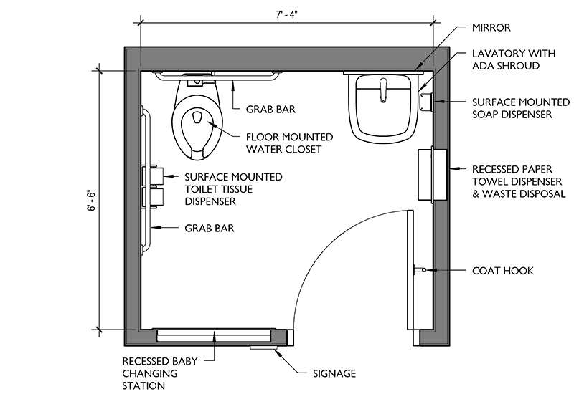

**Implementation Diagram:**

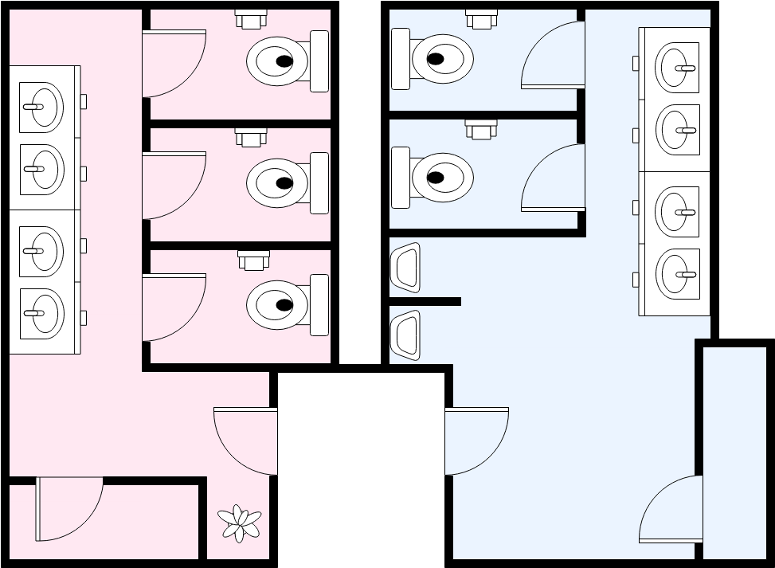

**Circuit Diagram:**

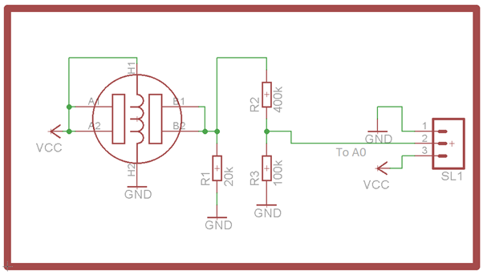

**Mobile Application :**

**Code:**

import javax.swing.*;

import java.awt.*;

import java.awt.event.ActionEvent;

import java.awt.event.ActionListener;

public class RestroomApp extends JFrame {

private boolean isOccupied = false;

private JLabel statusLabel;

public RestroomApp() {

setTitle("Restroom Occupancy App");

setSize(300, 150);

setDefaultCloseOperation(JFrame.EXIT_ON_CLOSE);

setLayout(new FlowLayout());

statusLabel = new JLabel("Restroom is Vacant");

add(statusLabel);

JButton occupyButton = new JButton("Occupy");

occupyButton.addActionListener(new ActionListener() {

public void actionPerformed(ActionEvent e) {

isOccupied = true;

statusLabel.setText("Restroom is Occupied");

}

});

add(occupyButton);

JButton vacateButton = new JButton("Vacate");

vacateButton.addActionListener(new ActionListener() {

public void actionPerformed(ActionEvent e) {

isOccupied = false;

statusLabel.setText("Restroom is Vacant");

}

});

add(vacateButton);

}

public static void main(String[] args) {

SwingUtilities.invokeLater(new Runnable() {

public void run() {

new RestroomApp().setVisible(true);

}

});

}

}

Output:

